Aetna

Suppose we are verifying Aetna insurance plans for below mentioned provider

**Provider name:** Sturgis Stephanie

**Address:** 29 Buckland St; Manchester; CT 06042

1. Enter below link in google chrome browser

<https://www.aetna.com/dsepublic/#/contentPage?page=providerSearchLanding&site_id=dse&language=en>

1. Enter Zipcode from address into the search box appearing under continue as a guest

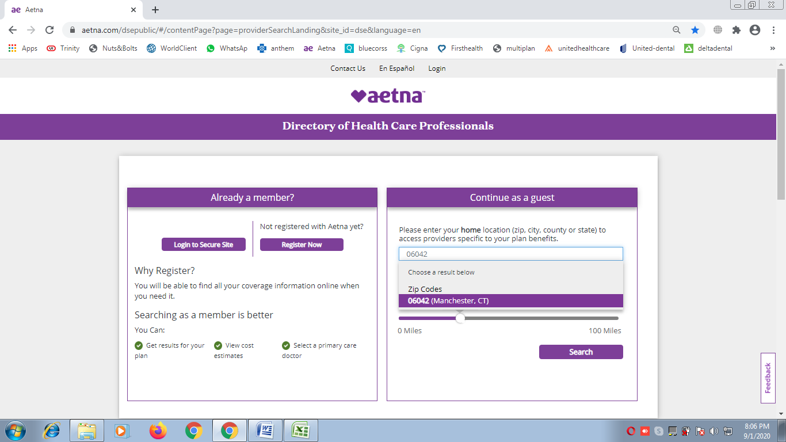

1. A dropdown will appear with multiple choices, and we have to pick right location address from there
2. Make sure distance should be selected as 100 miles
3. Hit search button

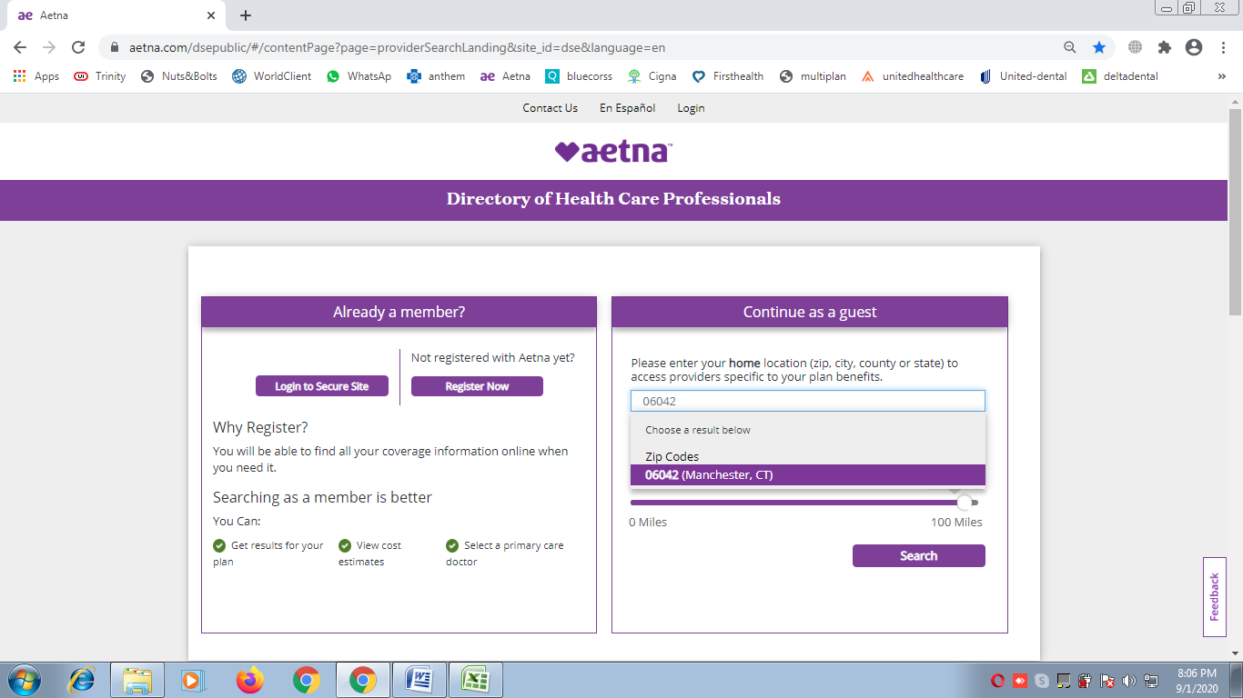

1. Click on **Skip plan selection**

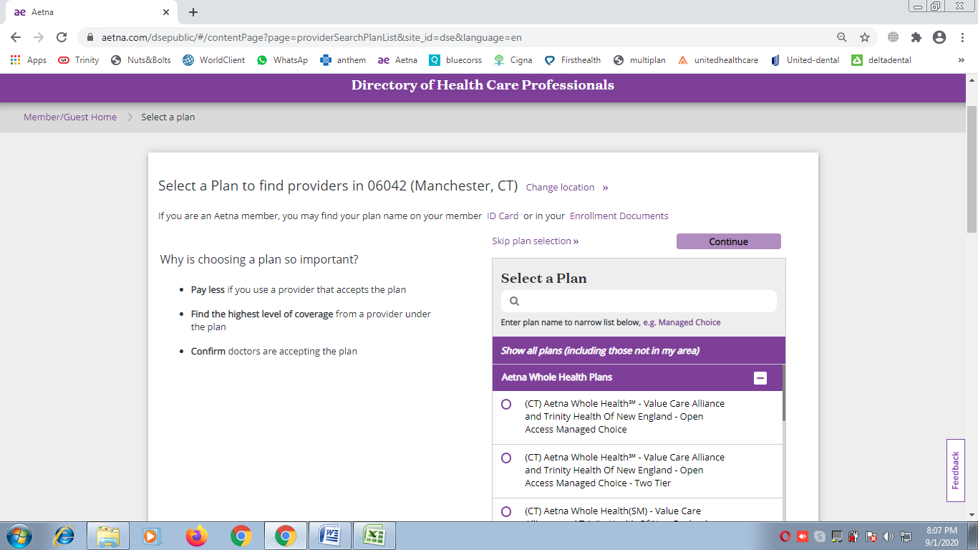

1. Next window will be the below one where we have to enter Provider name (Lastname Firstname) for example here we are looking for: **Sturgis Stephanie**
2. On Entering Provider name, multiple provider list can appear, we have to pick the right one
3. If same name appearing more then 1 times in dropdown, please pick first one

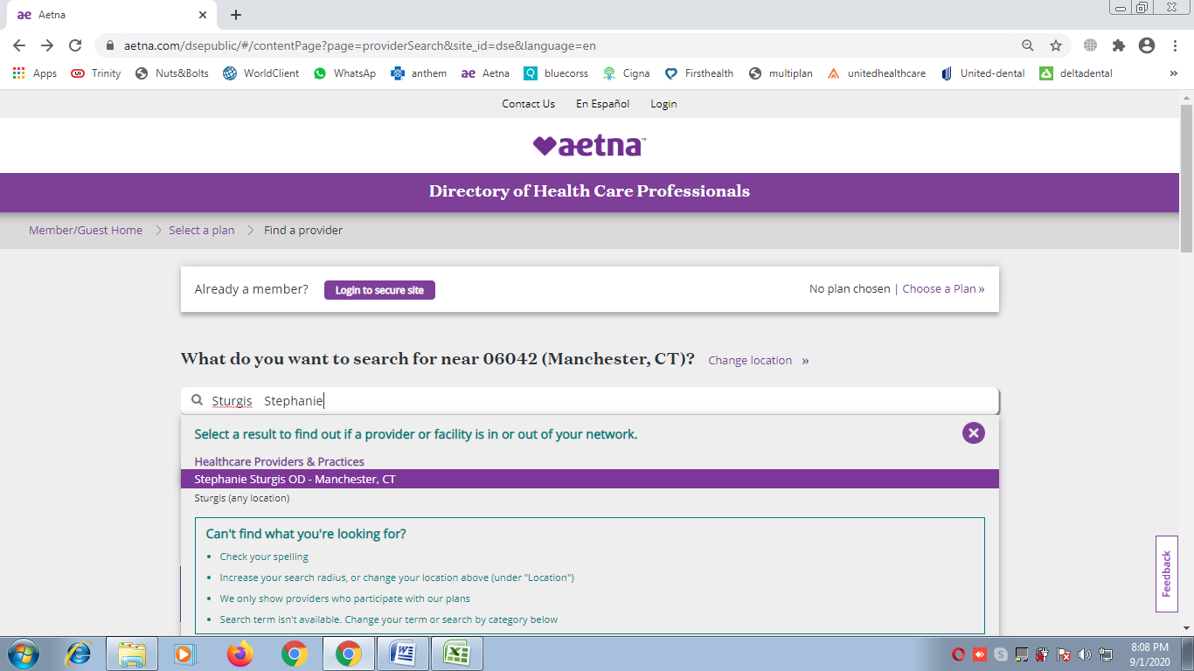

1. If Provider found then its details will appears, and we have to click on **See Accepted Plans**

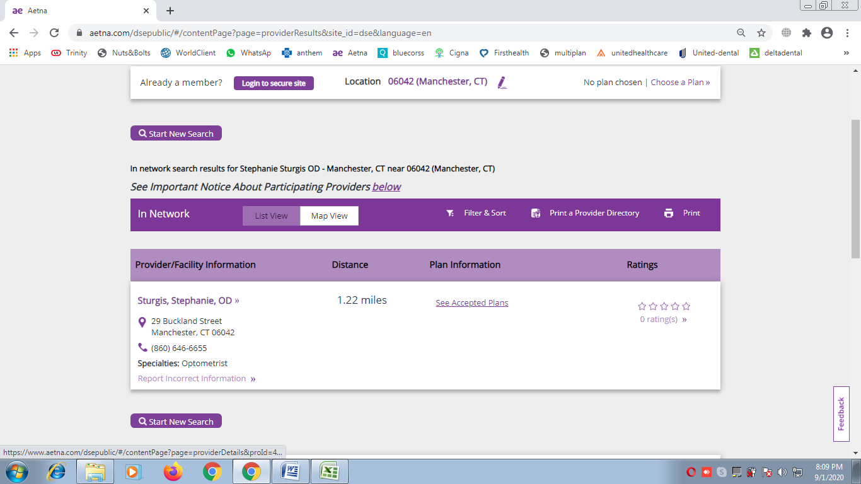

1. The insurance plans list will be appeared of searched provider under header (plan & network information)

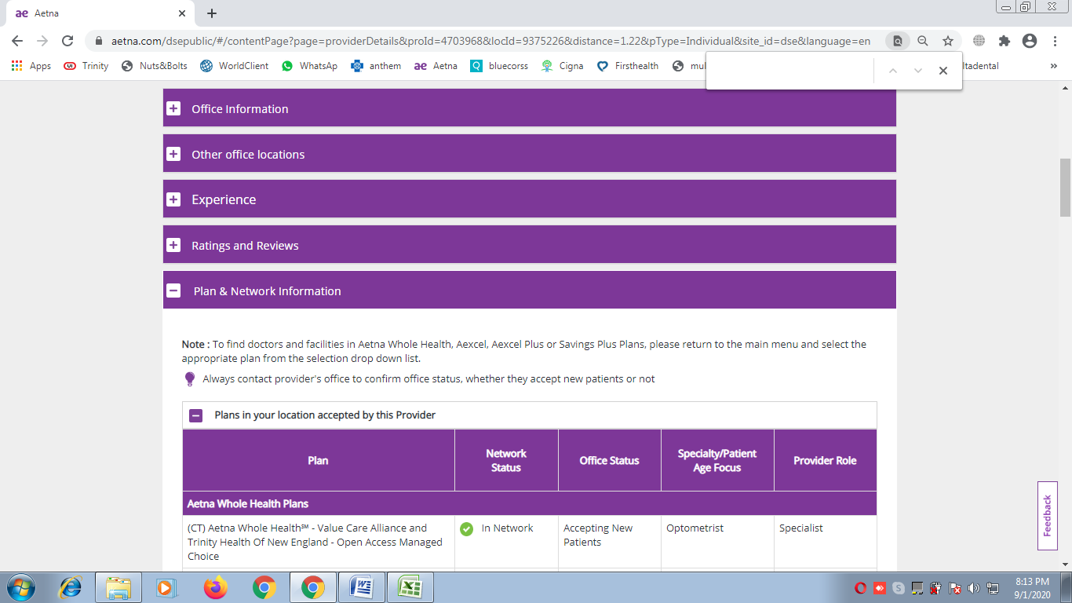

1. Pick all the plans appearing under headers

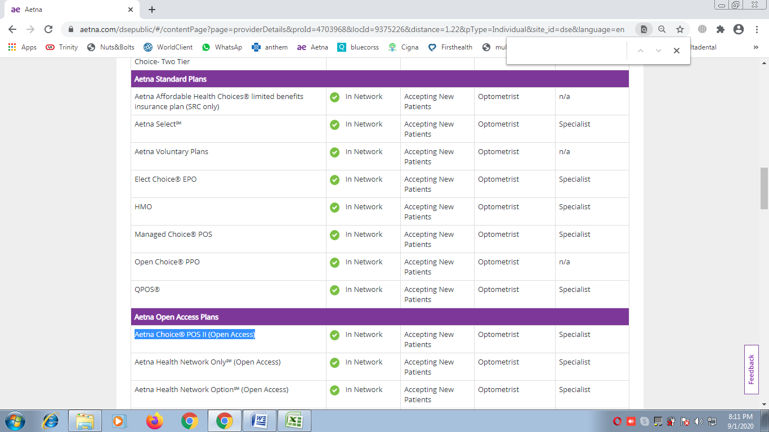

12 Record final output in excel in ‘J’ column in following format

Aetna: Plan name1 | Aetna: Plan name2 | Aetna: Plan name3 | Aetna: So on….